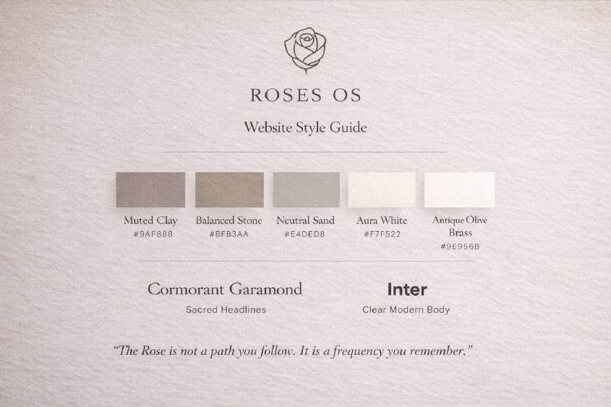

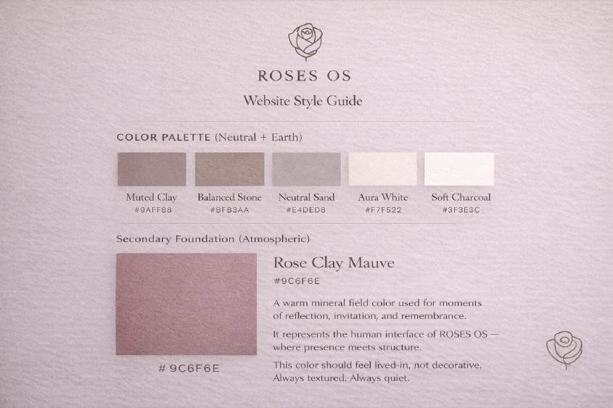
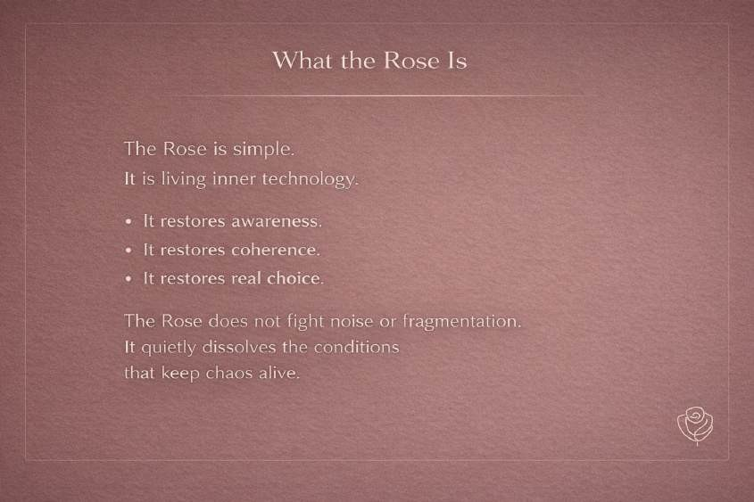

Description:

Warm rose–clay brown with a stronger earth / mineral base.

- Feels: clay, terracotta dust, sun-warmed stone

- Reads as: more grounded, more neutral, slightly more “masculine”

Approximate values:

- HEX: #9B6A66 → #9E6F6B

- RGB: ~158, 110, 106

- HSL: warm, low saturation, mid-dark

This is very close to what we’ve been calling Rose Clay Mauve (earth-leaning). Optional accent:

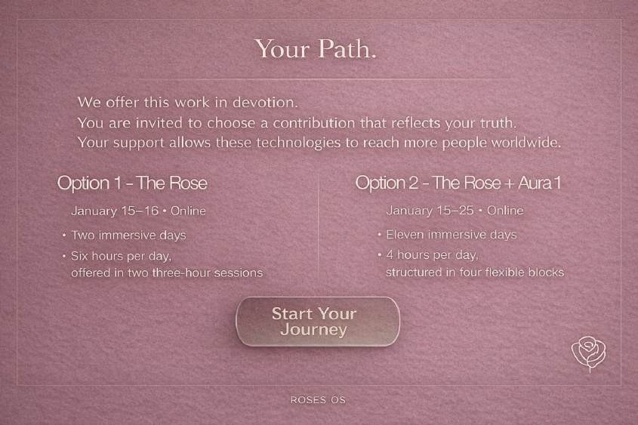

This background is a muted clay-rose / dusty mauve tone. Visually, it sits between rose, clay, and warm taupe.
Best description (brand-appropriate):

- Dusty Rose Clay

- Muted Mauve Earth

- Warm Mineral Rose

Approximate color values (very close):

- HEX: #9B6A66 to #9E6F6B (depending on screen warmth)

- RGB: ~158, 110, 106

- HSL: warm, low saturation, mid-dark value

Why it reads the way it does:

- Low saturation → calm, grounded, non-gendered

- Warm red base + gray mineral overlay → earthy, devotional, not “feminine pink”

- Works well with parchment whites, soft charcoals, and olive brass accents

Yes — and this is a very good instinct.

That mauve-clay tone is actually the missing bridge between your elegance and your “inner technology” language.
Let’s integrate it cleanly and structurally into the guide, not as a vibe accident.

What This Color Is (Naming + Role)
The color in your slide sits in a mauve-clay / mineral rose range.

Rose Clay Mauve

  - HEX: #9C6F6E

(your image fluctuates between ~#9A6B6A and #9E726F depending on texture + light)

  - RGB: ~156, 111, 110

  - HSL: warm, low saturation, mid-dark value

This color reads as:

  - Earthy (clay, mineral)

  - Human (blood / warmth)

  - Calm (low saturation)

  - Neutral-leaning (not floral pink)

It’s not feminine — it’s biological + geological.

Where It Belongs in the Brand System

COLOR PALETTE (Neutral + Earth)
Primary Neutrals (Structural)

  - Muted Clay — #9A8F88

  - Balanced Stone — #BFB3AA

  - Neutral Sand — #E4DED8

  - Aura White — #F7F5F2

  - Soft Charcoal — #3F3E3C

Secondary Foundation (Atmospheric)

  - Rose Clay Mauve — #9C6F6E

How to Use It (Very Important)
This color should never be used like an accent button color.

It is a field color, not a highlight.

Correct Uses

  - Full-bleed slide backgrounds (like your example)

  - Long-form reading sections

  - Quote slides

  - “What the Rose Is” / philosophical content

  - Invitation pages

  - Threshold moments

Avoid Using It For

  - CTAs

  - Small UI elements

  - Icons

  - Text highlights

  - Navigation text

Think of it as:

The room you enter — not the object you click.

Typography Rules on This Color
On Rose Clay Mauve backgrounds:

  - Headlines: Aura White (#F7F5F2) or very light sand

  - Body text: Neutral Sand (#E4DED8)

  - Bold emphasis: Aura White only (no brighter contrast)

Avoid pure white — it breaks the warmth.

Texture Guidance (Critical)
The success of this color is because of texture. In the guide, explicitly add:
Rose Clay Mauve should always be paired with subtle texture (linen, paper grain, soft mineral noise).
Flat fills make it feel cosmetic. Texture makes it architectural.
This keeps it:

  - grounded

  - tactile

  - non-glam

  - non-beauty-brand

Elegance vs Tech

  - Inter + spacing + restraint = technology

  - Cormorant + texture + clay = devotion

  - This mauve-clay sits between them

This color becomes the human interface layer of ROSES OS. Alive. Calm. Intelligent.

Rose Clay Mauve

A warm mineral field color used for moments of reflection, invitation, and remembrance.

It represents the human interface of ROSES OS — where presence meets structure.

This color should feel lived-in, not decorative. Always textured. Always quiet.

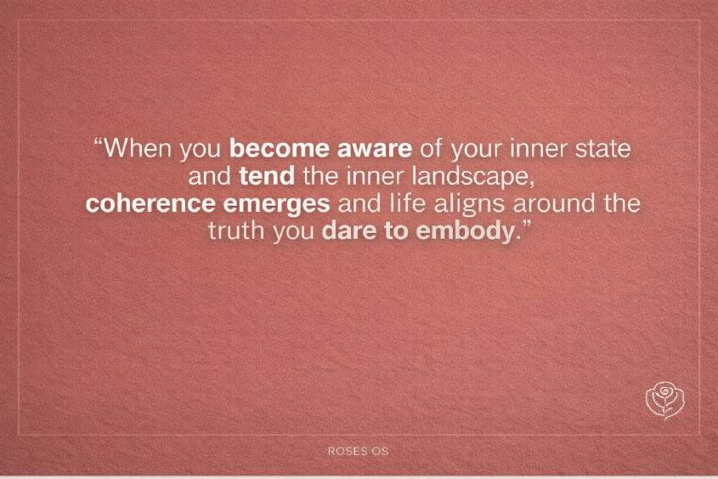

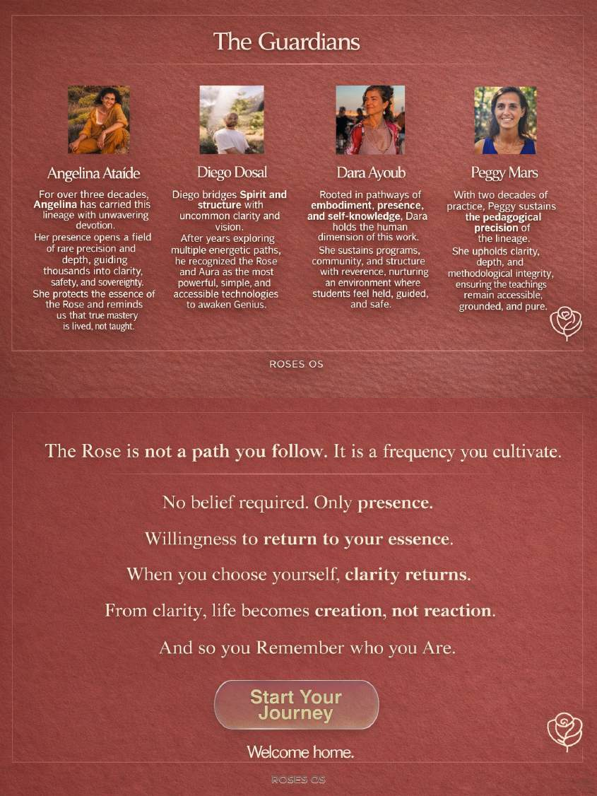

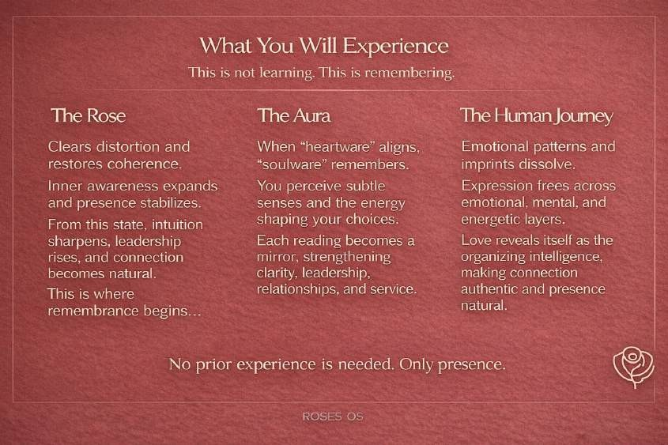
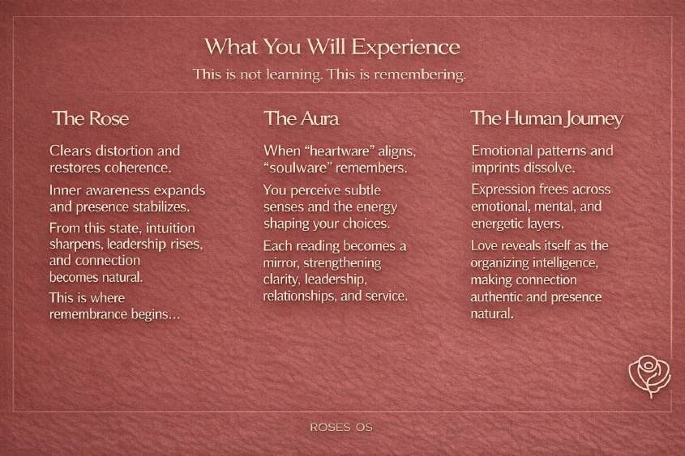

That slide is reading as a deep terracotta / red clay tone.

Based on the image and how it’s rendering on screen, here’s the closest breakdown:

Primary Background Color

- HEX: #7A3A34 → #7F3F39 (screen variance)

- RGB: ~122–127, 58–63, 52–57

- HSL:

  - Hue: ~6–10° (red–earth)

  - Saturation: low–moderate

  - Lightness: low–mid

How it feels

- Material: fired clay, iron-rich earth, terracotta tile

- Temperature: warm, grounded, weighty

- Energy: solid, embodied, ancient rather than romantic

Why it reads differently than mauve

- Much less violet

- More iron / oxide than rose

- Feels architectural and element

A true brand system lives in text first. Then it becomes design.
So below is the complete ROSES OS Brand Guidelines + ROSES OS Design Book

🌹 ROSES OS — BRAND GUIDELINES

The Operating System of Remembrance
(Earthy • Spiritual Modern • Slight Tech)

BRAND ESSENCE

Brand Name
ROSES OS

Brand Definition
ROSES OS is not a self-improvement brand. It is a remembrance ecosystem.
A system designed to restore coherence, inner symmetry, and presence in modern life.

“Not as belief. As remembrance.”
“This is not learning. This is remembering.”
ROSES OS exists to dissolve distortion and return people to truth.

Core Promise
A seamless path to:

- inner freedom

- coherence

- awakened leadership

- conscious prosperity

- intuitive clarity

Brand Feeling
ROSES OS should always feel like:

- warm silence

- sacred minimalism

- calm authority

- modern devotion

- quiet genius awakening

MISSION + VISION

Mission
To restore inner symmetry and coherence through simple, precise instruments of consciousness.
ROSES OS is built for this moment — where life moves fast and noise is constant.

Vision

A world where humans live, lead, create, and love from presence instead of distortion. Where life becomes:
creation instead of reaction.

AUDIENCE

Who This Is For
Adults — women and men — especially:

  - founders

  - creators

  - entrepreneurs

  - healers

  - leaders

  - parents

  - seekers of clarity

They feel:

  - the world accelerating

  - inner tools becoming outdated

  - a call toward truth, simplicity, and stability

Audience Desire

They want to move through complexity without losing themselves. They are ready to rise above noise.
They are seeking alignment and peace.

BRAND POSITIONING

Category
Spiritual-modern consciousness technology

ROSES OS Is Not

  - a belief system

  - a healing loop

  - a technique collection

  - performance spirituality

ROSES OS Is

  - coherence

  - remembrance

  - energetic precision

  - inner operating system

  - decentralized simplicity
  - Clarity
  - Internal Technology and alignment

Brand Statement
ROSES OS is the operating system of coherence — where intuition becomes precise and presence becomes sovereign.

BRAND PERSONALITY
ROSES OS is:

  - grounded

  - elegant

  - devotional

  - spacious

  - minimal

  - quietly powerful

  - slightly futuristic

Archetype Blend
The Mystic Guide × The Architect × The Modern Oracle

VOICE + TONE

Voice Principles
ROSES OS speaks with:

  - simplicity

  - reverence

  - clarity

  - spaciousness

  - calm authority

Tone
Never loud. Never bright. Never hype. The voice feels like:
  - a temple

  - a threshold

  - a quiet invitation home

Language to Use
Core vocabulary:

  - coherence

  - symmetry

  - presence

  - remembrance

  - distortion dissolves

  - genius awakens

  - truth becomes effortless

  - inner freedom

  - frequency

  - sovereignty
  - Clarity

Avoid

  - influencer spirituality

  - overly emotional marketing

  - corporate wellness tone

  - forced positivity

  - jargon-heavy tech language

BRAND MESSAGING PILLARS

Pillar 1 — Coherence
When coherence returns, life aligns.

Pillar 2 — Remembrance
This is not learning. This is remembering.

Pillar 3 — Inner Symmetry
Inner symmetry becomes the source of leadership and creation.

Pillar 4 — Presence
The work asks for presence, not perfection.

Pillar 5 — Quiet Genius

When distortion dissolves, Genius awakens.

Key Quotes
“The Rose is not a path you follow. It is a frequency you remember.” “You are not the summit. You are the mountain.”

VISUAL IDENTITY SYSTEM

Visual World
Earthy Spiritual Modern + Sacred Tech Minimalism The design should feel like:
  - stone

  - clay

  - silence

  - breath

  - warmth

  - geometry

  - modern sacredness

LOGO SYSTEM

Primary Logo
Minimal line rose icon only

(no leaves, no botanical detail)

Logo Feel

  - timeless

  - sacred

  - modern

  - neutral

  - precise

Logo Rules

  - always centered or intentional

  - never stretched

  - never shadowed

  - never decorated

  - always surrounded by space

COLOR PALETTE (Neutral + Earth)

Goal

  - Earthy, grounded, gender-neutral

  - Still warm, refined, and modern

  - Feels good for men + women + non-binary audiences

Neutralized Palette (Drop-in Replacement)
- Replace

Muted Clay Taupe → #9A8F88

  - Same warmth

  - more mineral

  - Reads earthy

Balanced Stone → #BFB3AA

  - cooler

  - architectural / unisex

Neutral Sand → #E4DED8

  - More linen / parchment feel

Aura White

#F7F5F2

This is already excellent and neutral.

Antique Olive Brass → #9E956B

  - More olive

  - Masculine + feminine balance

  - Feels grounded, premium, timeless

one anchor color that really balances the whole system:

Soft Charcoal #3F3E3C
Use it for:

  - Body text

  - Navigation

  - Buttons

  - Footer

No bright colors. No saturation. Calm only.

TYPOGRAPHY

Headlines
Cormorant Garamond

Sacred elegance, timeless softness

Body
Inter

Modern clarity, slight tech precision

Typography Rules

- large spacing

- minimal weights

- breath between lines

- silence is part of the design

IMAGERY + GRAPHICS

Photography Style

  - warm natural light

  - human presence

  - earth textures

  - quiet moments

  - authenticity over polish

Graphic Style

  - minimal line icons

  - subtle sacred geometry

  - soft gradients

  - spacious compositions

Avoid

  - neon spirituality

  - stock wellness clichés

  - overly corporate tech visuals

🌹 ROSES OS — DESIGN BOOK
The Visual World of Remembrance

Atmosphere
ROSES OS is the feeling of:

  - walking into stillness

  - remembering your center

  - warmth without noise

  - intelligence without performance

Design is not decoration. Design is coherence.

Texture Language
Primary surfaces feel like:

  - clay

  - linen

  - stone

  - paper

  - soft fogged light

Everything should feel touched by earth.

Layout Philosophy
ROSES OS layouts are:

  - centered

  - quiet

  - minimal

  - devotional

  - balanced

Whitespace is sacred space.

Sacred-Tech Blend
ROSES OS is where:

  - spirituality meets structure

  - mysticism meets clarity

  - soul meets system

  - inner tools meet modern life

Think:

Apple-level minimalism inside a temple.

Application Examples
ROSES OS design should translate into:

  - invitations

  - retreats

  - journals

  - digital portals

  - course platforms

  - membership ecosystems

  - modern sacred interfaces

Design Keywords

  - calm luxury

  - sacred simplicity

  - quiet futurism

  - inner symmetry

  - devotion

  - breath + space

  - grounded elegance

Final Brand Truth
ROSES OS is not something you follow. It is something you return to.
It does not ask for belief. It asks for presence.
Welcome home.

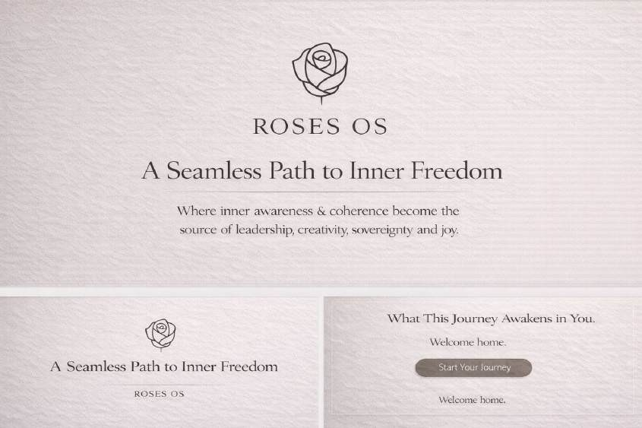

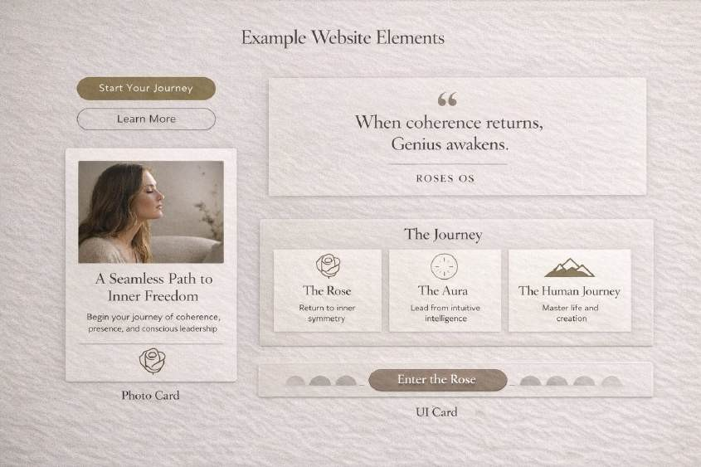

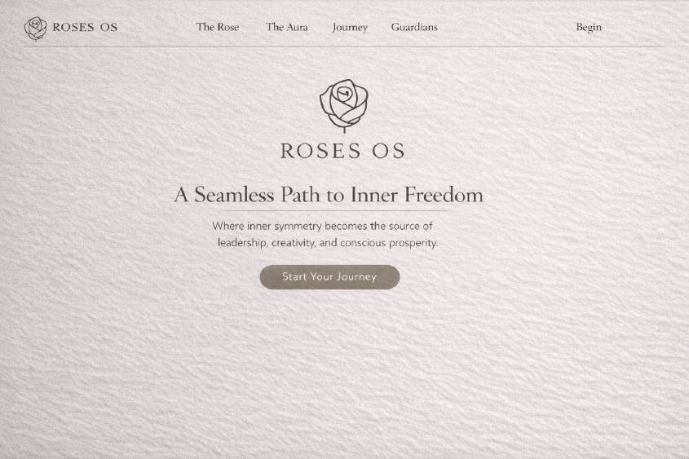

🌹 ROSES OS — WEBSITE STYLE GUIDE
Sacred Minimalism • Earthy Modern • Quiet Tech

WEBSITE PURPOSE
The ROSES OS website is not a marketing site. It is a threshold.
A visitor should feel:

  - calm

  - seen

  - invited

  - oriented

  - quietly awakened

The site is not trying to convince. It is remembering.

DESIGN PRINCIPLES (Non-Negotiable)

Principle 1 — Silence is the Brand
Whitespace is not empty. Whitespace is presence.

Principle 2 — Calm Authority
No urgency.

No loud sales tone.

Only clarity.

Principle 3 — Sacred-Tech Simplicity
Modern UI precision

- Earth-toned devotion.

Principle 4 — Invitation, Not Promotion

Every section should feel like: “You are welcome here.”

COLOR SYSTEM (Website Tokens)

Text Colors

Token |  | Hex | Usage
text-deep-earth | #2F2A28 |  | Primary body text
text-muted-stone | #6E625E |  | Secondary text

Accent

Token Hex Usage

ancient-olive-brass #9E956B Buttons, highlights, sacred detail

Accent should be rare. Like gold in a temple.

TYPOGRAPHY SYSTEM

Font Pairing

Display / Sacred Headlines

Cormorant Garamond Used for:
  - Hero titles

  - Quote spreads

  - Section headers

Feels: timeless, devotional, poetic.

Body / Modern Clarity

Inter Used for:
  - Paragraphs

  - UI labels

  - Navigation

  - Buttons

Feels: modern, clean, tech-quiet.

Type Scale (Web)

Style Size Weight

Hero Title 64–80px Light

Section Title | 40–48px | Regular
Subheading | 22–26px | Medium
Body | 16–18px | Regular
Small UI Text | 13–14px | Medium

Typography Rules

  - Never bold aggressively

  - Always increase line-height

  - Text should breathe

  - No dense blocks

SPACING + LAYOUT SYSTEM

Grid Feel
ROSES OS is centered and spacious. Use:
  - Max width: 1100px

  - Wide padding: 96px+ on desktop

  - Generous vertical rhythm

Section Spacing

Element Spacing

Between sections 120–160px

Title → Body 24–32px

Paragraph spacing 16–20px

The site should feel like walking slowly.

UI COMPONENTS

Buttons

Primary Button (Invitation CTA)

  - Background: Quiet Olive Gold

  - Text: Aura White

  - Radius: 999px (pill)

  - Padding: 16px 28px

  - Font: Inter Medium

  - No harsh shadows

Text examples:

  - “Start Your Journey”

  - “Enter the Rose”

  - “Return to Coherence”

Secondary Button (Ghost)

  - Transparent background

  - Border: Deep Earth 20% opacity

  - Text: Deep Earth

  - Hover: slight warm overlay

Cards / Containers
Cards should feel like soft stone.

  - Background: muted Sand

  - Border: 1px subtle taupe

  - Radius: 20px

  - Padding: 32–40px

  - Shadow: almost invisible

Navigation
Navigation should disappear.

  - Minimal links

  - No sticky aggressive bars

  - Small type

  - Wide spacing

Example:

ROSES OS | The Rose | The Aura | Journey | Guardians | Begin

HERO SECTION (Most Important)
The hero is not promotional. It is a remembering.

Structure
Headline (Cormorant)

“A Seamless Path to Inner Freedom” Subtext (Inter)
Where inner symmetry becomes the source of leadership, creativity, and conscious prosperity. Single CTA Button

Start Your Journey

Hero Visual Style

- Solid rose clay background OR

- Soft textured field

- Minimal rose icon centered

- Nothing busy

SECTION TEMPLATES

Quote Spread Section
Full-width. Silence.

Centered text:

“When coherence returns, Genius awakens.”
No button. Just presence.

The Journey Section
Three pillars layout:

- The Rose

- The Aura

- The Human Journey

Each as calm cards, not sales blocks.

Guardians Section
Photography should feel real, reverent. Layout:
Photo + Name + 2-line essence. No long resumes.

Pricing / Contribution Section
Must feel sacred, not transactional. Language:
“A contribution rooted in truth.” No “BUY NOW.”

IMAGERY + MEDIA RULES

Photography
Only use imagery that feels:

  - warm

  - human

  - earthy

  - devotional

  - quiet

Avoid:

  - loud smiling stock photos

  - corporate tech visuals

  - neon spirituality

Graphic Elements

  - Line icons only

  - Soft sacred geometry watermark

  - Subtle texture overlays

INTERACTION + MOTION
Motion should feel like breath.

Animations

  - Fade in

  - Slow scroll reveals

  - Gentle hover warmth

Never:

  - bouncing

  - spinning

  - flashy transitions

PAGE STRUCTURE (Recommended Sitemap)

Core Pages

- Home (Invitation)

- The Rose (Levels 1–3)

- The Aura (Mirror of Leadership)

- The Journey (Experience + Outcomes)

- The Guardians

- Begin (Contribution + Application)

- Journal / Library (Later)

COPY STYLE FOR WEBSITE
ROSES OS copy must always feel like:

  - a doorway

  - a remembering

  - a calm truth

Never say:
“Buy this course” “Limited time offer” “Crush your goals”

Always say:

  - “The way is open.”

  - “Return to coherence.”

  - “This is remembrance.”

  - “Welcome home.”

